Machine Description | The machine was vulnerable to a Remote File Inclusion (RFI) vulnerability that allowed unauthenticated Remote Code Execution (RCE), leading to initial system access and further privilege escalation.
Target IP | 192.168.0.104
Vulnerability Name | Outdated Apache HTTP Server 2.4.29 and Outdated Web Application Plugins Detected
Service Version | Apache HTTP Server 2.4.29 (Ubuntu)
CVSS score and Severity | 9.8 Critical
Attack Vector | CVSS:3.0/AV:N/AC:L/PR:N/UI:N/S:U/C:H/I:H/A:H
Proof of Concept | STEP 1: Find out the IP address using netdiscover  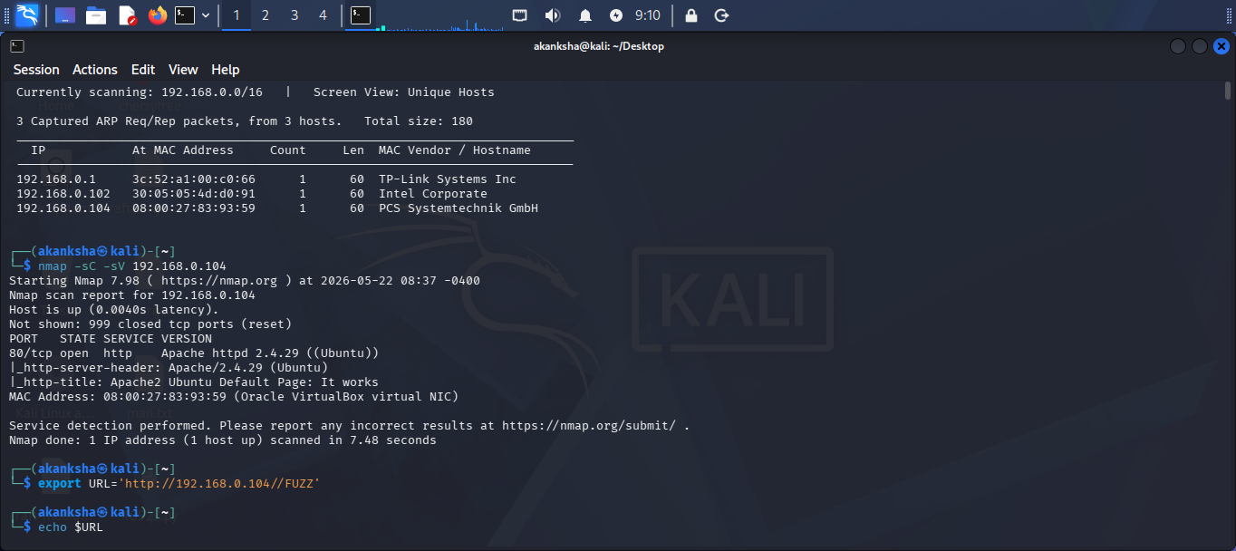  STEP 2: Scan open ports and services using nmap tool    STEP 3: Let’s start enumerating What is running on port 80  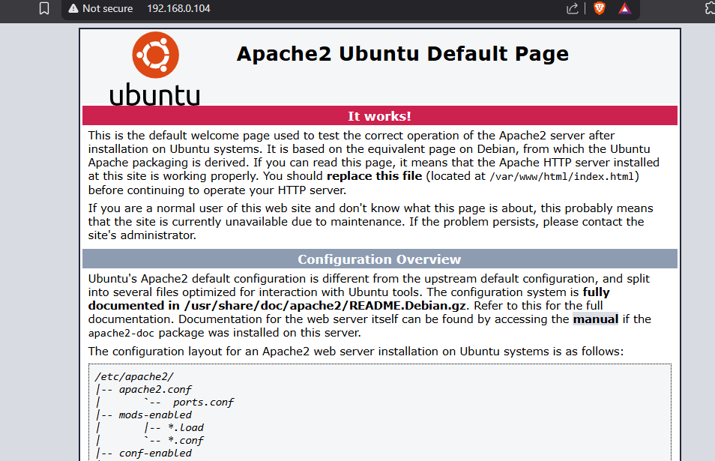  - Let’s looking forward for available files on server  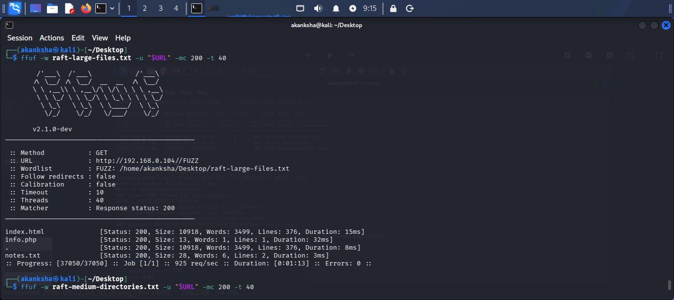  - Looking for available directories on server by fuzzing  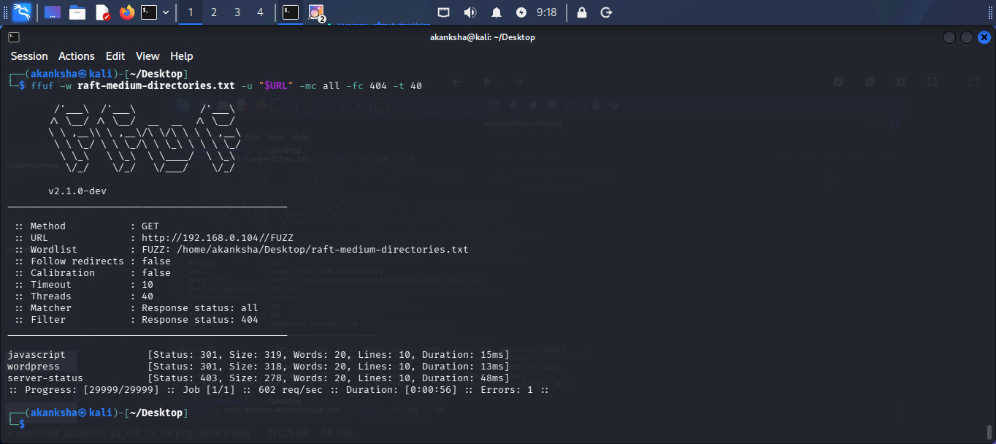  STEP 4: Let’s do enumeration on wordpress directory  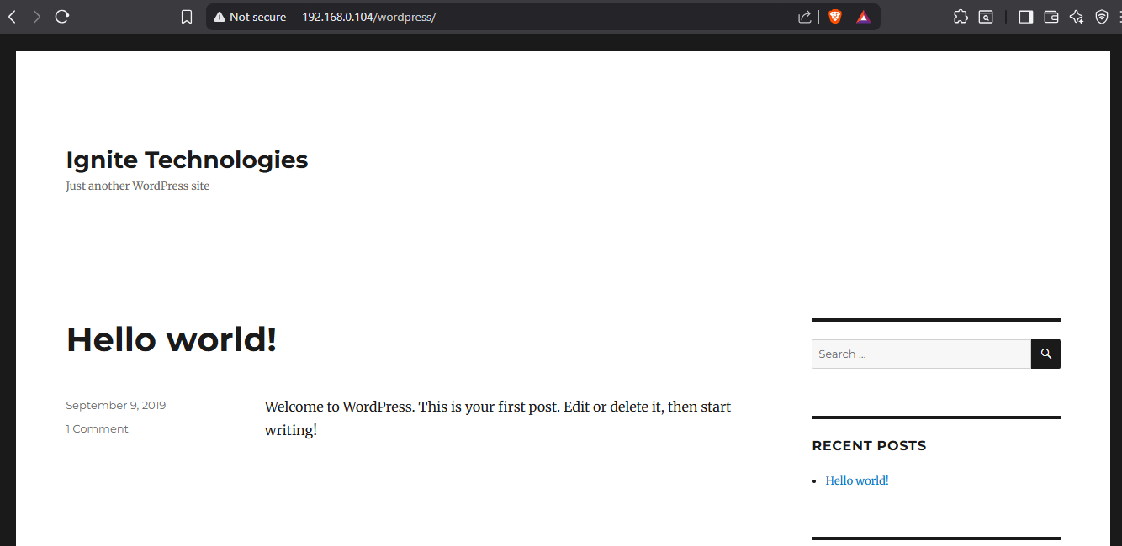  - By Doing wpscan we find the outdated plugins  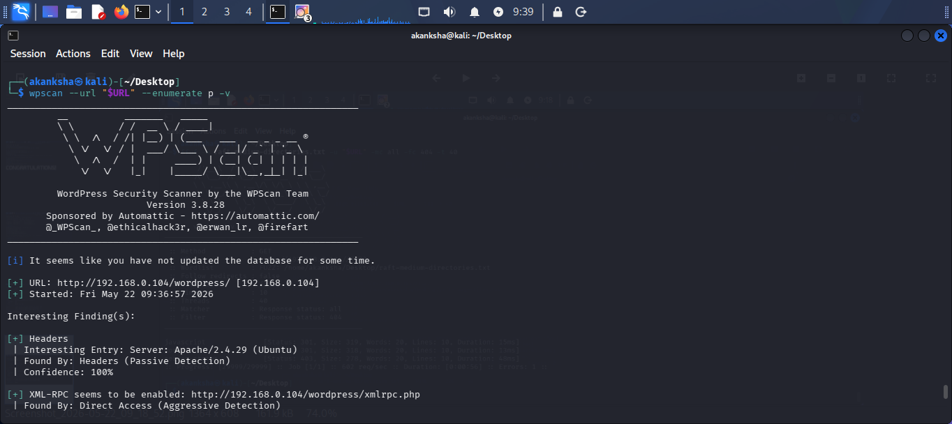  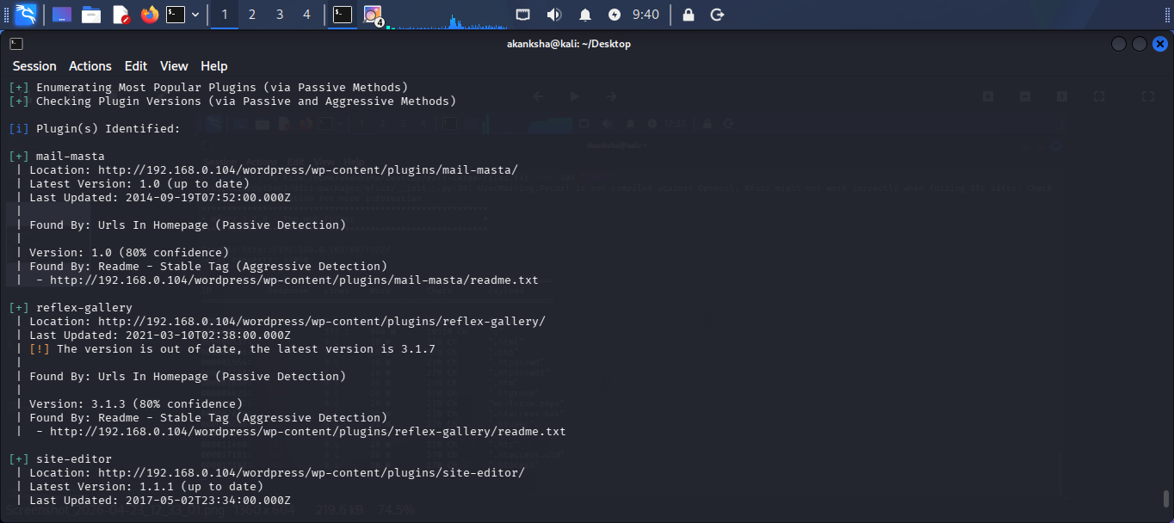  - Found out out dated plugin reflex gallery. let’s search more about reflex gallery on exploited  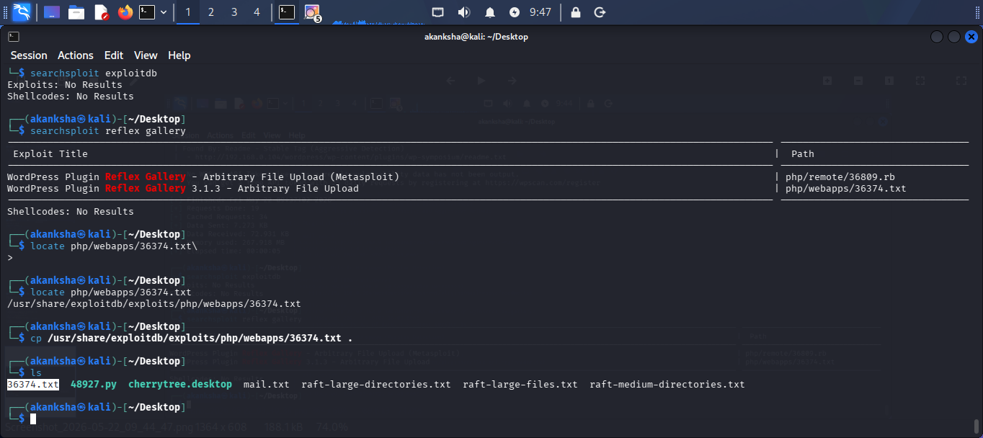  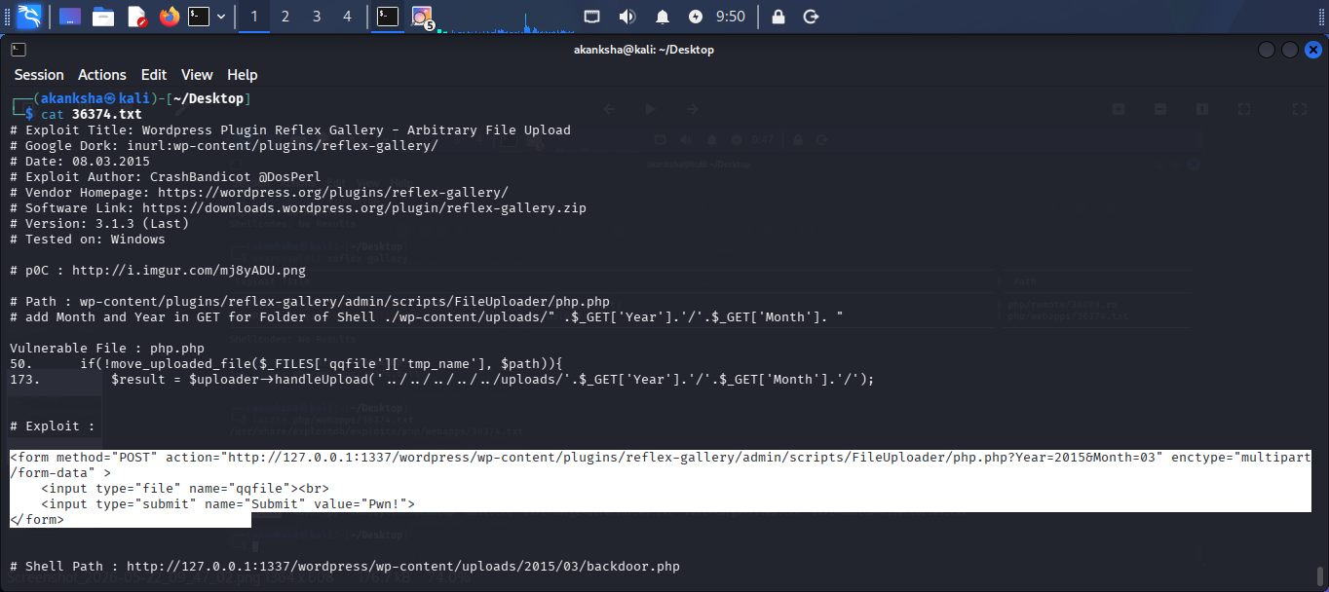  - We got two valid username during wpscan enumeration aarti and admin  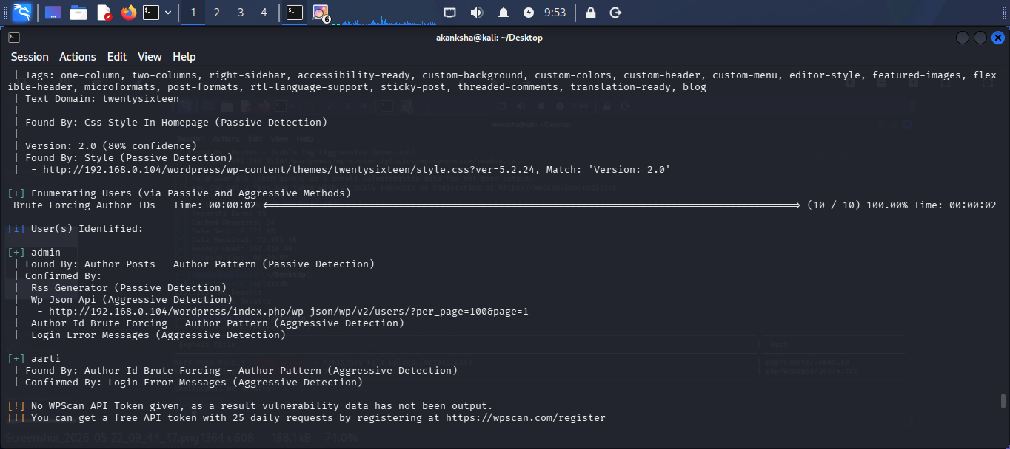  STEP 5: let’s build the exploit  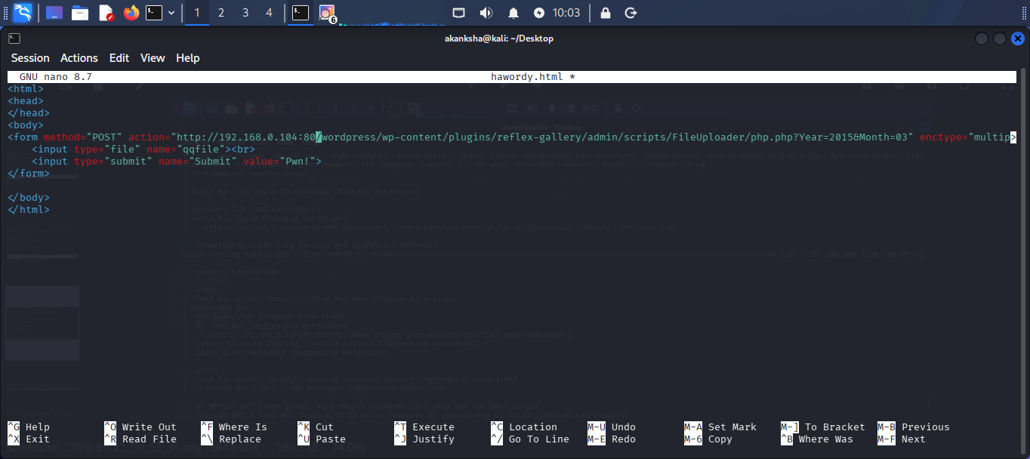  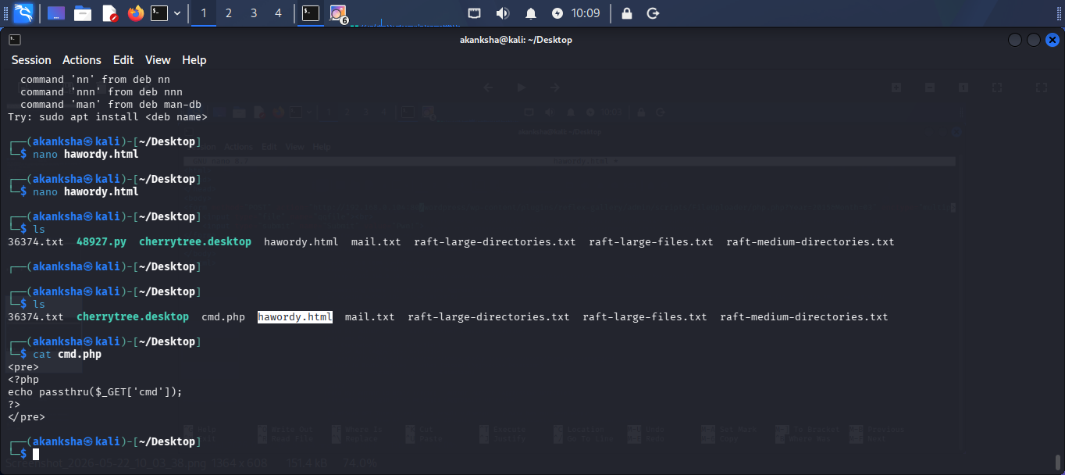  - Lets try to open hawordy.html by command firefox (firefox hawordy.html)  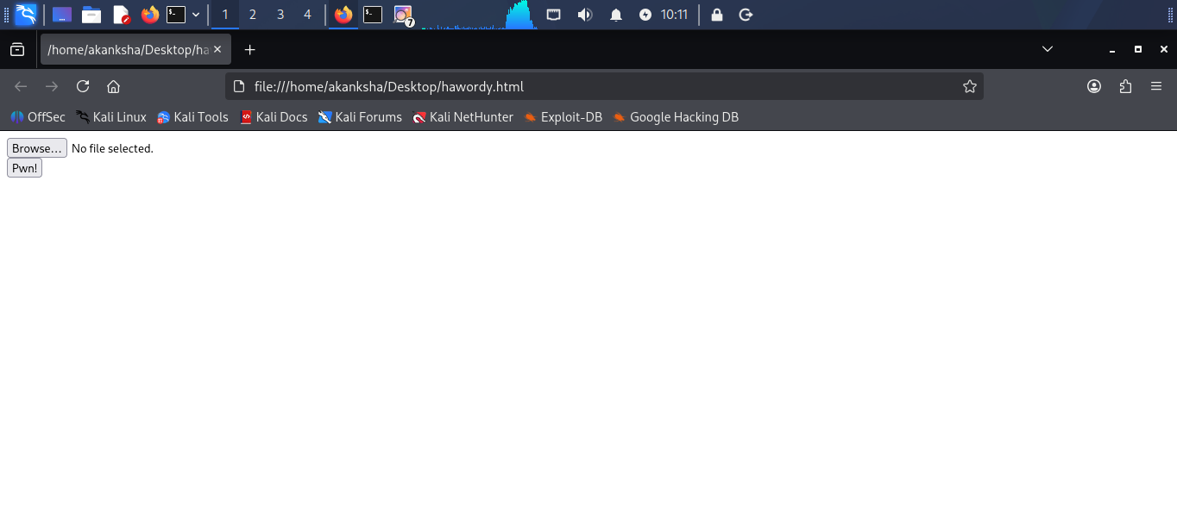  http://192.168.0.104/wordpress/wp-content/plugins/reflex-gallery/admin/scripts/FileUploader/php.php  - Let’s upload cmd.php. before uploading file visit the page  “http://192.168.0.104/wordpress/wp-content/plugins/reflex-gallery/admin/scripts/FileUploader/php.php?Year=2015&Month”  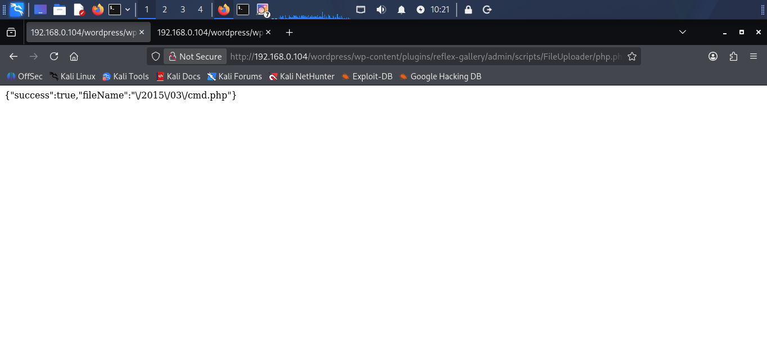  - We uploaded successful let’s visit “/wp-content/uploads/2015/03/” we can see our php shell  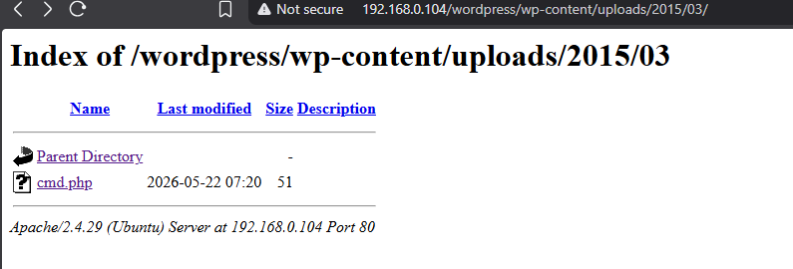  - We Got shell here  STEP 5 – Lets make interactive shell  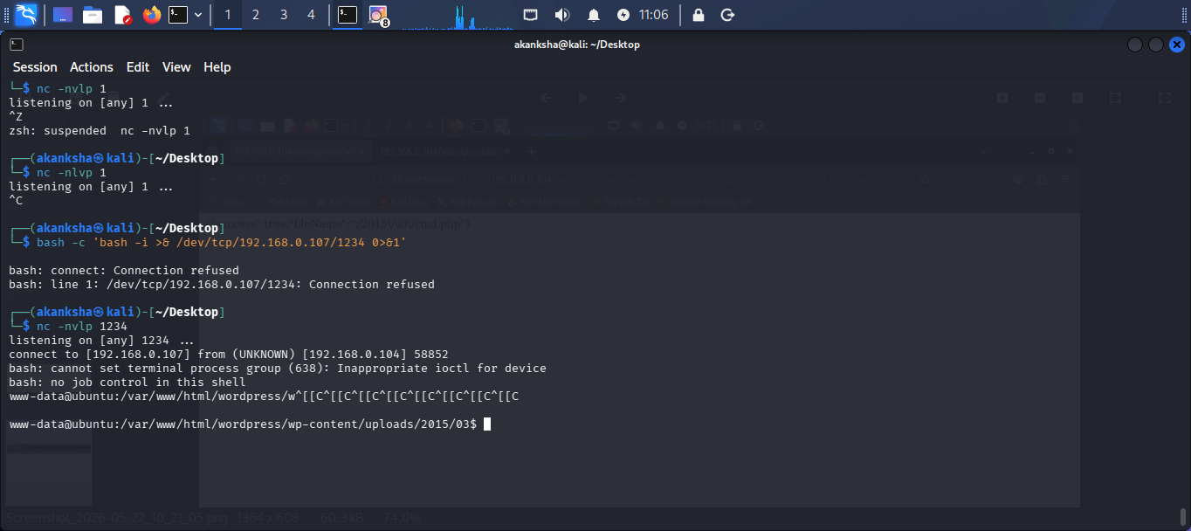  STEP 6: Lets do privilege escalation by insecure permission  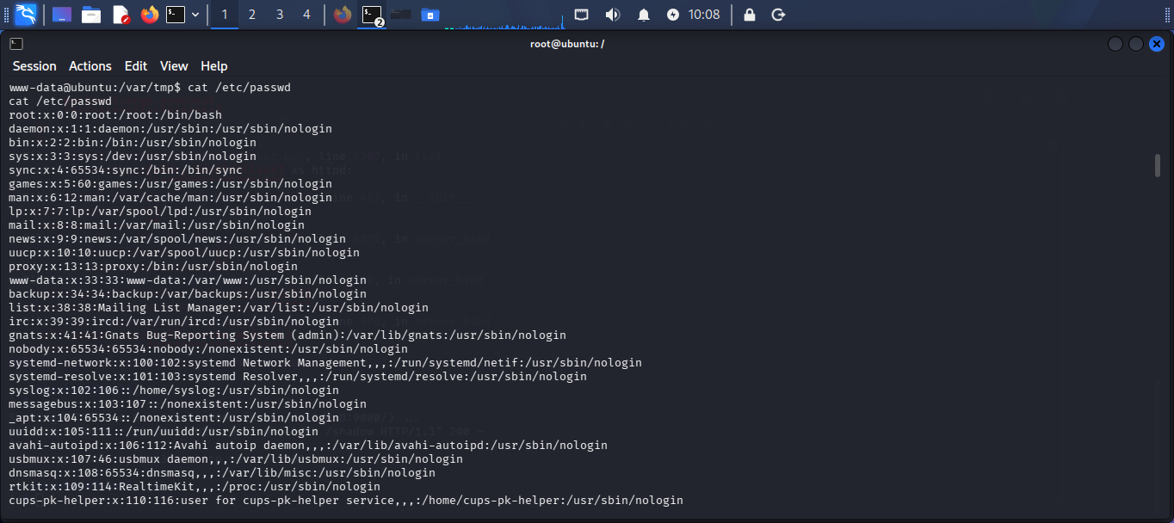  - As we know that all username sand passwords are stored at path /etc/passwd we modified that passwd file.  - First copy all the content from this file and paste it into new nano file in our system  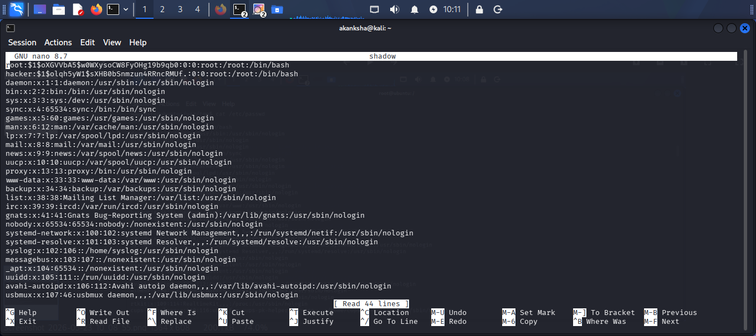  - Add new username and password and modify this file and save it  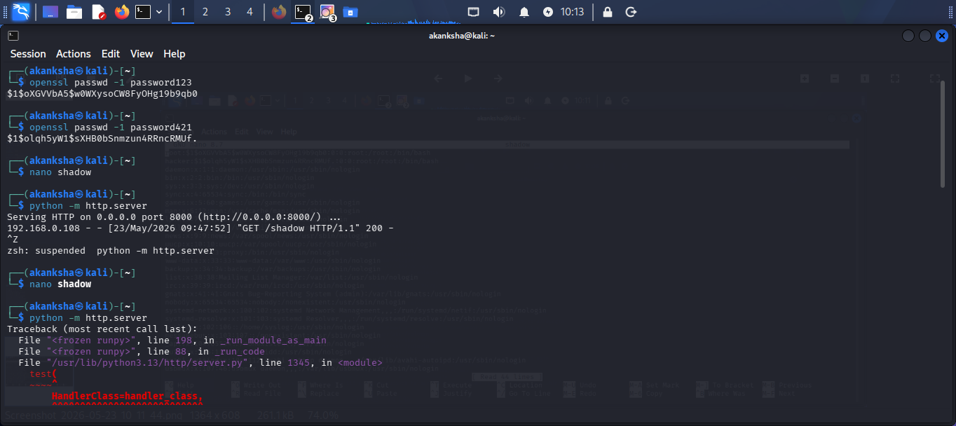  - Start our own server to get this file on vulnerable system  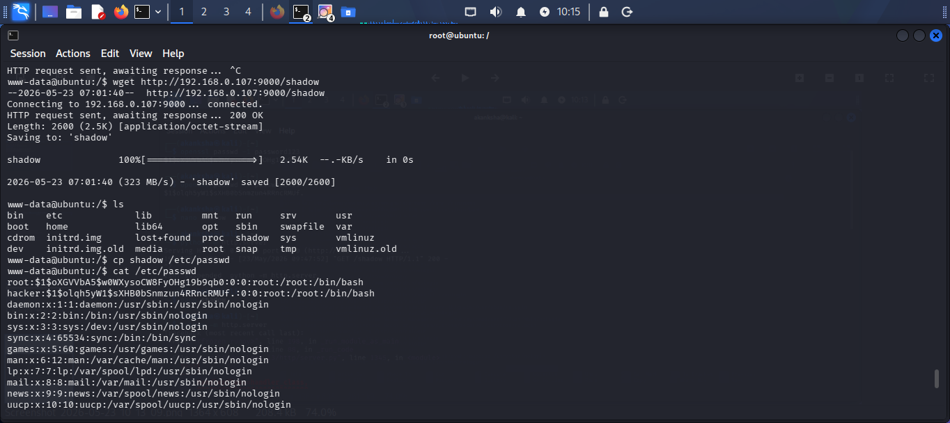  - Get this modified file by wget command  - After getting file replace it by original /etc/shadow file  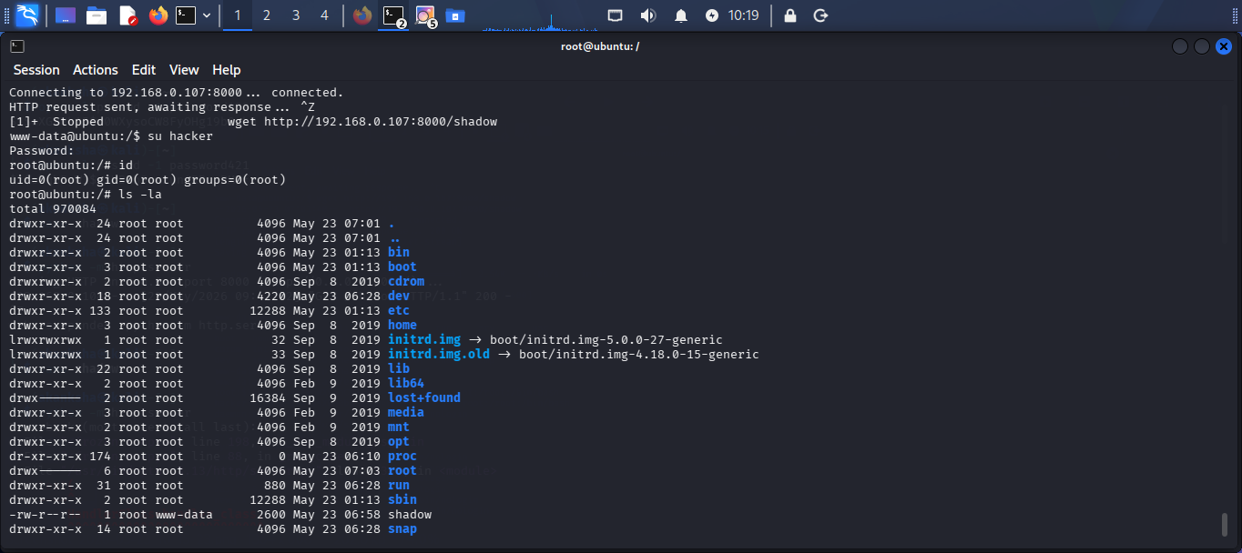  - Here we got root access  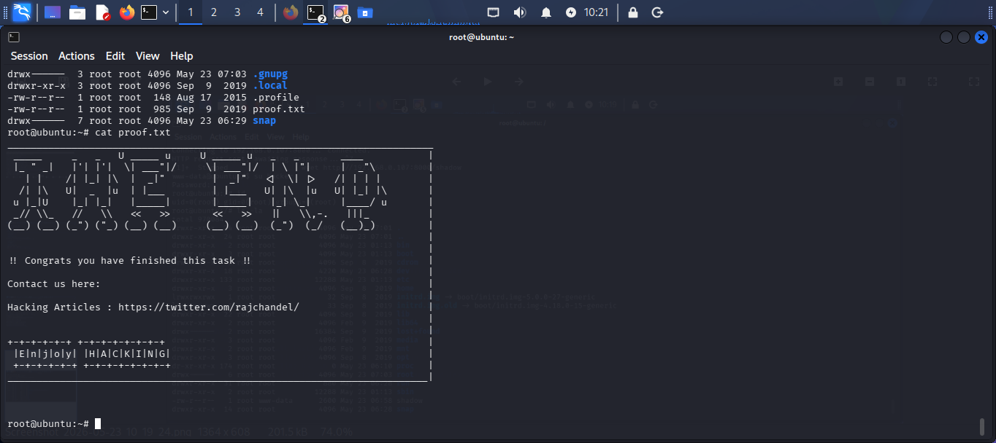  - Finally we successfully found flag which is in proof.txt
Impact | - An attacker can access the system without permission  - Malicious commands can be executed on the server  - Sensitive files and information may get exposed  - The attacker can gain full administrator (root) access  - Complete control of the machine can lead to system misuse or downtime
Remediations | - Keep Apache server and web application plugins updated  - Disable Remote File Inclusion functionality if not required  - Validate and sanitize all user input properly  - Apply proper file and directory permissions  - Regularly monitor and patch vulnerable services and applications
Reference | https://www.vulnhub.com/entry/ha-wordy%2C363/

